Team Contribution Statement
We used Jira as a project management tool to organize and manage the development process. We divide task based on personal strength while ensuring the workload are evenly divided
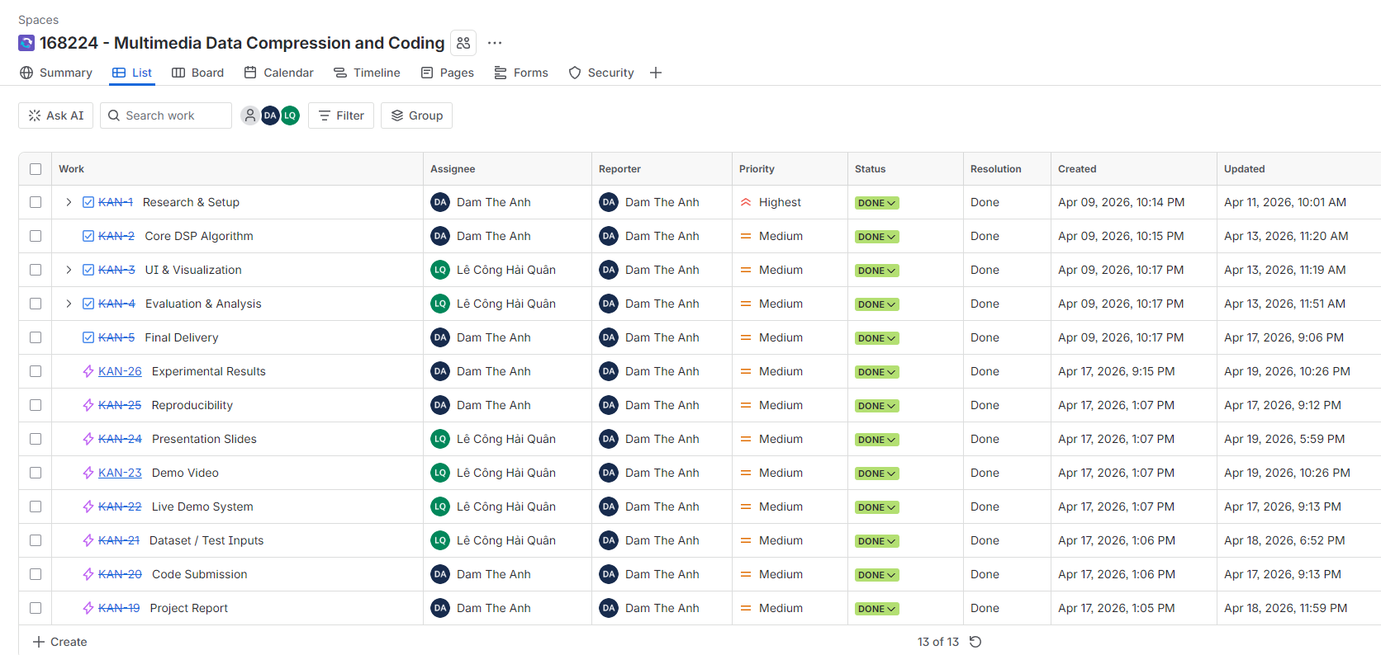

Furthermore, we also use Github for easier collaboration when coding the application
